

**CENTELLA ASIATICA**

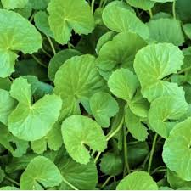**BOTANICAL NAME: *Centella Asiatica***

**FAMILY:** Apiaceae

SYNONYMS:

ENGLISH: Gotu Kola

HINDI: Vidya Patra

TAMIL: Vallarai

TELUGU: Saraswathi Aakulu

**CHEMICAL CONSTITUENTS:**

Sarawathi plant contains pentacyclic triterpenoids and trisaccharide derivatives

It includes asiaticoside,brahmoside, asaitic acid and

Brahmic acid (madecassic acid).

**USES:**

* Treatment of skin damage as well as for circulatory enhancement.
* Many plants associated with Saraswati are used in religious rituals and offerings. For example, the Saraswati plant is commonly used in ceremonies dedicated to the goddess of knowledge and wisdom.
* They are used to decorate altars and spaces during festivals such as Vasant Panchami, which is dedicated to Saraswati.
* Some plants linked with Saraswati are used in traditional medicine practices for their supposed benefits. For example, the *Saraswati* plant might be used in herbal remedies for various ailments, although specific uses would depend on the exact species.
* Many of these plants are valued for their beauty and are used in gardens and landscapes to add aesthetic appeal.
* These plants often symbolize wisdom and learning, making them popular in educational institutions and libraries.